Homework 2.1: Features of Functions Name: _________________________
Math 3

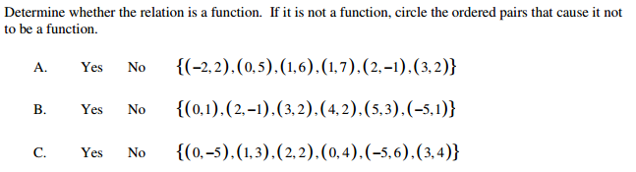

- Which of the following graphs represent functions? Circle your answers. If it is a function, state the domain and range. If the graph is not included, make a table and graph the function by hand.

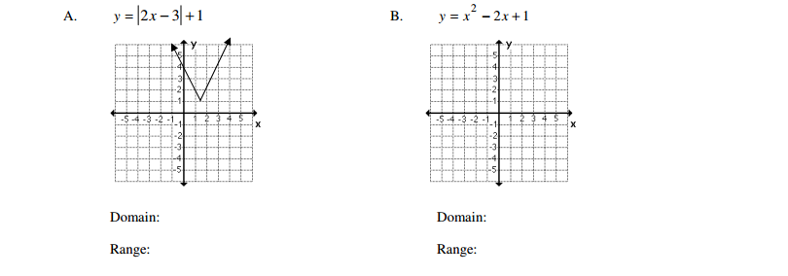

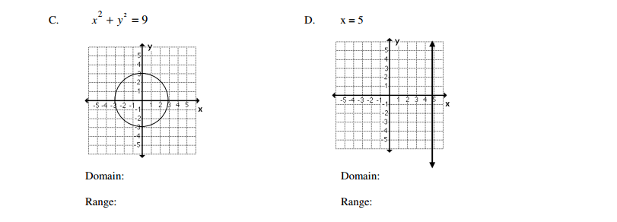

- Graph the following functions, and then find each of the following.

- Absolute Value: $f\left(x\right)=-\left|x\right|+7$ Shape: _____
x | -3 | -2 | -1 | 0 | 1 | 2 | 3 | 4
y

x-intercept:

y-intercept:

Max or Min:

Vertex:

Interval Increasing:

Interval Decreasing:

- Quadratic: $f\left(x\right)={-(x+1)}^{2}-7$ Shape: _____
x | -4 | -3 | -2 | -1 | 0 | 1 | 2
y

x-intercept:

y-intercept:

Max or Min:

Vertex:

Interval Increasing:

Interval Decreasing:

For questions 3a-3b:
- What similarities do you see between the vertex and the equation?

- Do you believe the vertex has any bearing on where the graph is located? Explain your reasoning.

- What part of the equation do you think gives the graph its shape?

